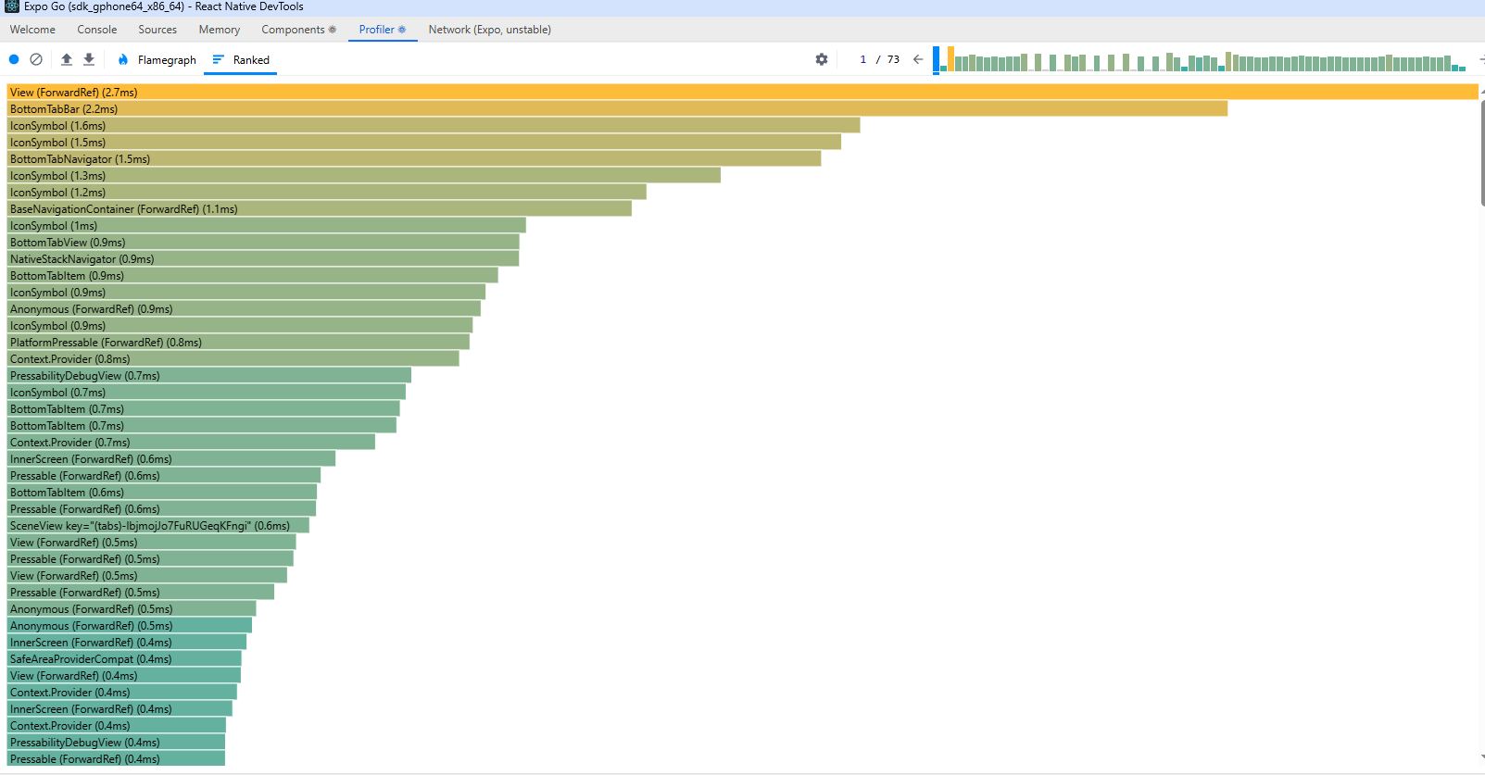

Scenario:
- Starting on the home page, navigate to the report hazard page and complete the form. Submit to the firebase table, navigate back to the home page.

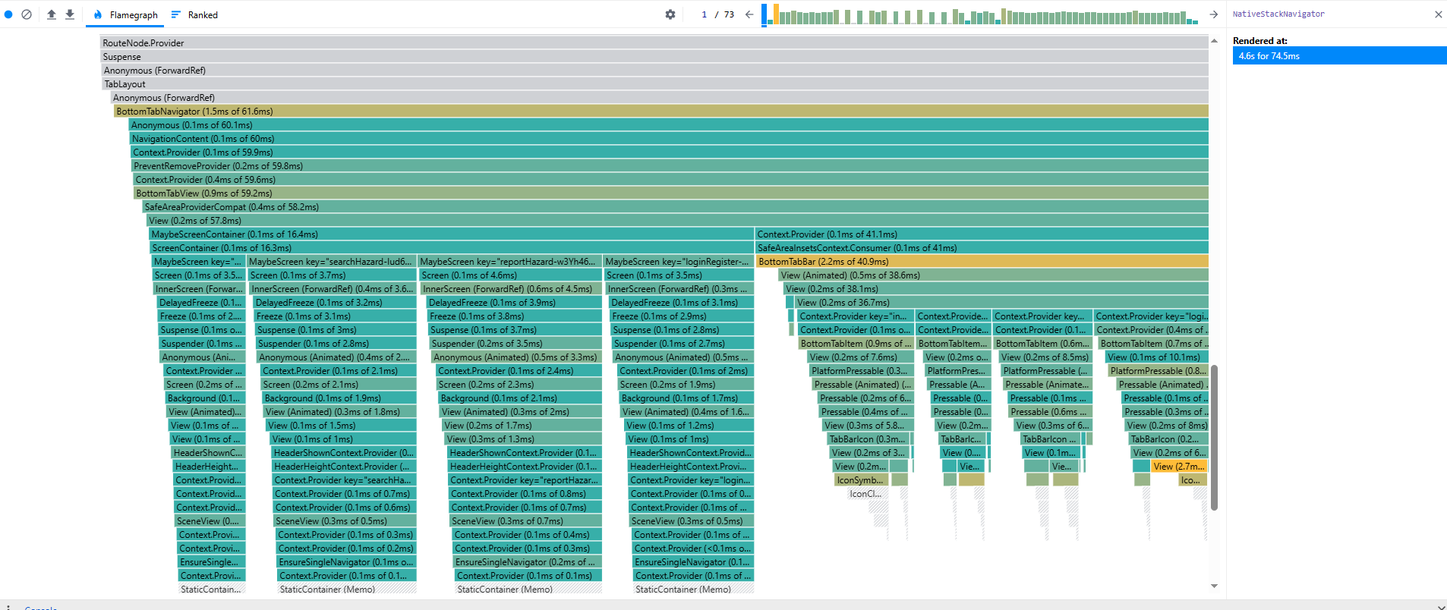
Here’s a small breakdown of the problem area during the scenario from above. The above graphs are indicating an issue has risen around the rendering of the “BottomTabBar”.
The likely cause of this is the code surrounding the Tab navigation bar continuously rendering each time a new page is selected. We can elaborate further on the issue here to fulfil the task.

Scenario:
- I attempted this testing scenario with dark mode selected. The same navigational sequence was followed with quite a substantial decrease in resource intensive functions due to the performance load dark mode encounters.

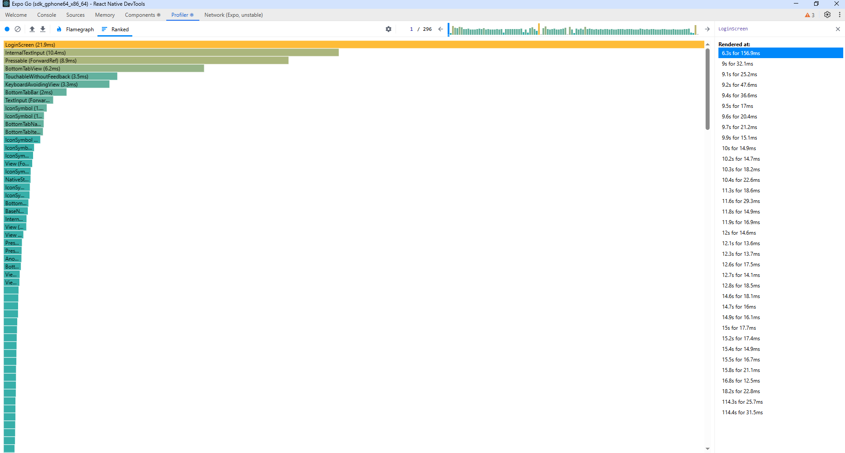

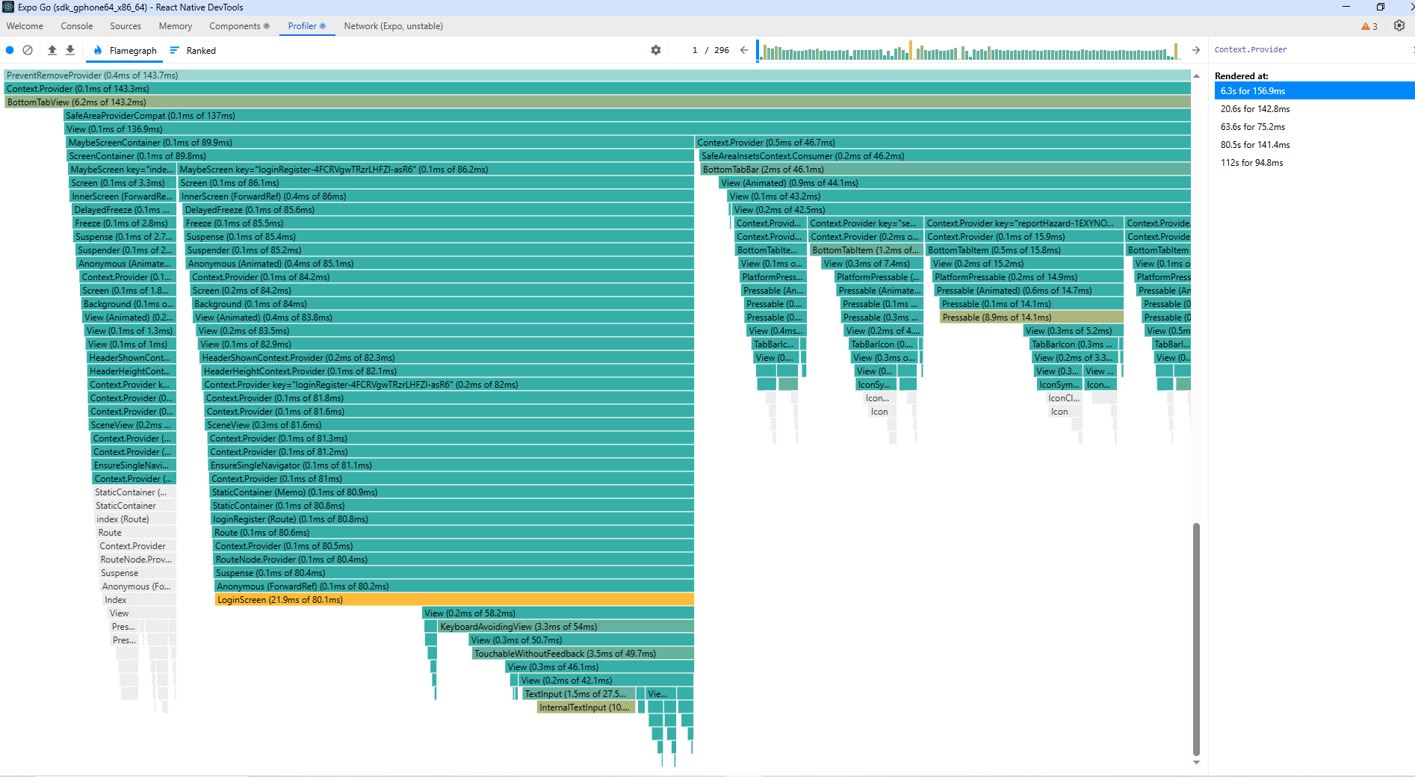
From the above performance tests, the resource intensive function has shifted from the ‘BottomTabBar’ and is now focused more on the Login Screen in general.
To troubleshoot further and improve the functionality of the application, a review of the Login screen and _layout.tsx files will take place to observe the resource intensive functions of each page to identify the culprit.

